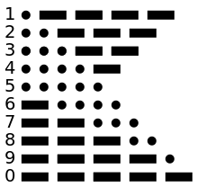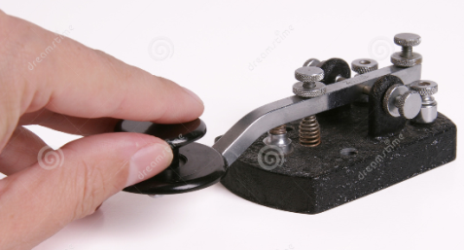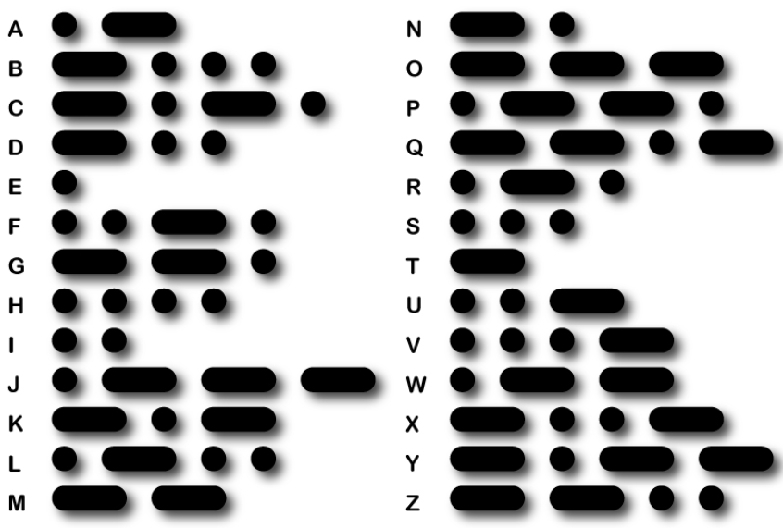

***Morse Code***

Emergency request for help using SOS can be sent many ways:   
keying a radio on and off, flashing a mirror, toggling a torch etc.   
SOS is not three separate characters, it is a “prosign” SOS keyed without gaps between characters

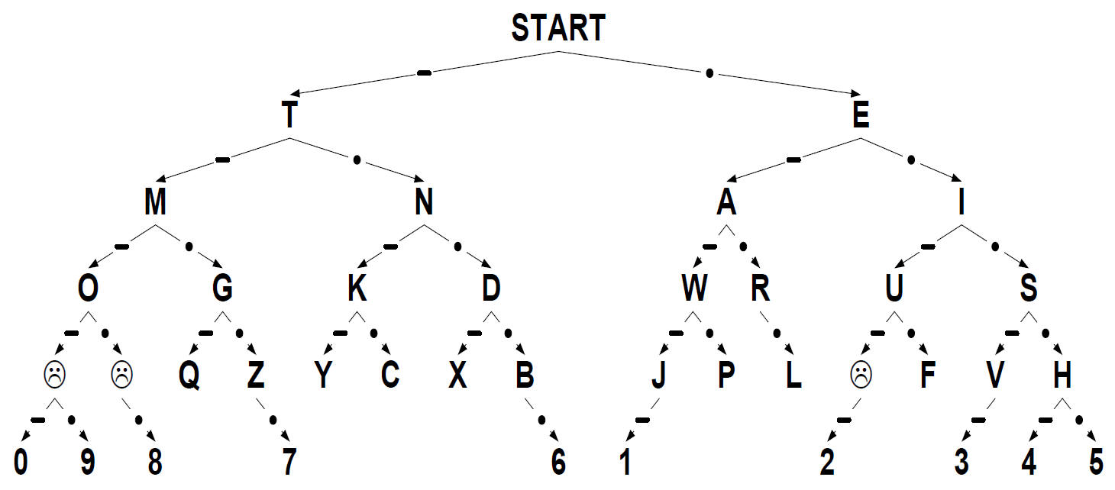

System first used in about 1844 making indentations on a paper tape when electric currents received.

Some mobile phones use morse for “SMS”   
to signal that a text or   
“Small Message Service” message  
has been received

Developed by American painter & inventor Samuel F.B. Morse (1791–1872) with Joseph Henry, & Alfred Vail.